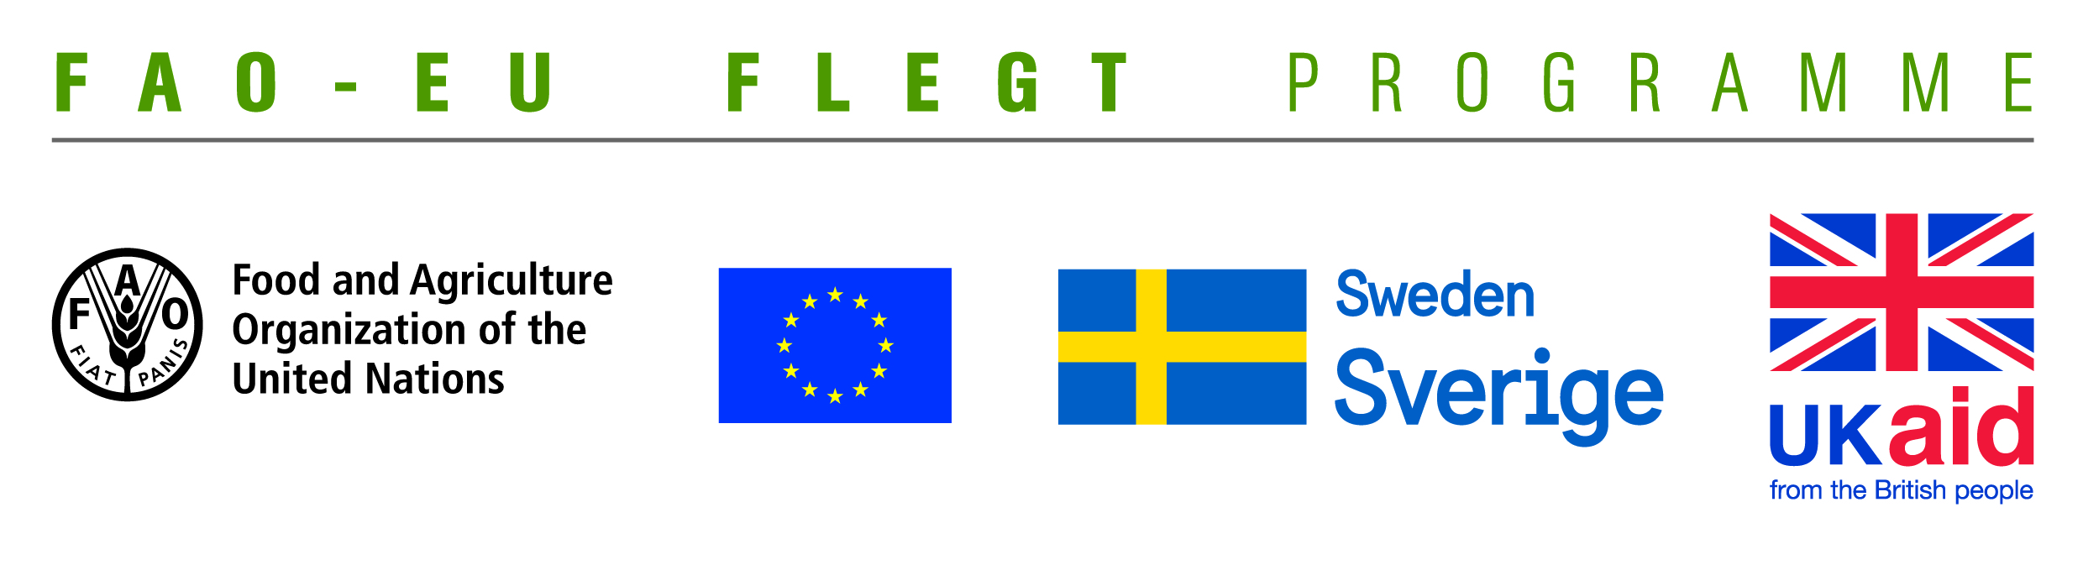
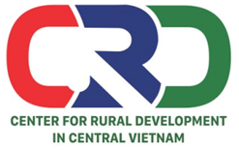

TERMS OF REFERENCE (TOR)
Project name | Supporting small business holders comply with the LD requirements in order to effectively participate in national and global legal timber supply chains
Job Title | Facilitating a project closing workshop to share results obtained, experiences and lessons learnt from the project implementation
Recruiting Organization | Centre for Rural Development in Central Vietnam (CRD)
Location | Ha Noi, Da Nang or Hue
Time | In February 2020

- Background information
Centre for Rural Development in Central Vietnam (CRD) implements the project titled “Supporting small business holders comply with the LD requirements in order to effectively participate in national and global legal timber supply chains” funded by the Food and Agriculture Organization of the United Nations (FAO). The project aims to supporting small business holders to comply with the legal requirements, Vietnam Timber Legality Assurance System and Organizations Classification System requirements in order to effectively participate in national and global legal timber supply chains. Its specific objectives are:
- To understand the technical capacity needs of provincial level stakeholders such as business associations, civil society organizations (CSOs), and provincial Forest Protection Department (FPD) to provide support to small business holders;
- To increase CSOs and business associations capacity to provide technical support to small business holders; and
- To develop an approach for future independent/participatory monitoring of Vietnam Timber Legelity Assurance System (VNTLAS) and Organization Classification System (OCS) implementation by CSOs and business associations.
It is expected that the project would obtain four outcomes: (i) The Service Provider will produce, achieve or deliver the following outputs or outcomes; (ii) Rapid assessment for better understanding of capacity-building needs of local stakeholders at provincial level conducted and assessment methodology validated; (iii) Capacity of CSOs and other local partner organizations to provide targeted technical support to micro-enterprises for Legality Definition (LD) compliance strengthened and tested; (iv) CSOs and local associations have the capacity to undertake independent/participatory monitoring of VNTLAS and OCS implementation; (v) Monitoring, evaluation and visibility framework developed.
Under the project, a project closing workshop will be carried out with participants from FAO, VNFOREST, forestry agencies, Core Group on VPA/FLEGT, NGOs, CSOs and wood enterprises. This workshop aims sharing results, experiences/lessons learnt during project implementation to stakeholders. CRD is looking for a consultant with professional knowledge and good experience to facilitate and moderate the workshop.
- Tasks and duties
- Prepare workshop agenda
- Prepare workshop evaluation form
- Review and give comments on presentations
- Facilitate and moderate a one – day workshop
- Synthesize information and write report
- Deliverables
- A workshop agenda
- A workshop evaluation form
- A post - workshop report
- Qualifications
- At least Master degree in forestry, development studies, enterprise management, project management or other relevant fields.
- Good knowledge on forestry laws and VPA/FLEGT, LD, VNTLAS related issues.
- At least 5 years of working experience in facilitating and moderating workshops and trainings
- Experience in working with NGOs, CSOs and timber processing enterprises is prefered.
- Good skills in stimulating group discussions.
- Good skills in synthesizing, processing information and writing report.
- Ability to work independently and in a team.
- Excellent verbal and written communication skills in both English and Vietnamese.
Interested candidates are invited to send CVs via email no later than 6 February, 2020: namnv@crdvietnam.org with cc huongnl@crdvietnam.org

